Student Services Chatbot System

Research Project Sponsored by

Silver Oak University

**Submitted by**

Student Name Institute Name

KALSARIYA JAYRAJ H. 2201030400040

**Silver Oak Institute of Technology Bachelor of Technology Department of Computer Engineering (05)**

GADHER CHIRAG N. 2201031800013

CHOVATIYA HARSHIL S. 2201030400017

GADARIYA BHUPENDRASINGH S. 2201031800051

Department Name : Computer Engineering



Silver Oak University

# INDEX

|  |  |  |
| --- | --- | --- |
| **Sr NO** | **Content** | **Page No** |
| 01 | Abstract | 4 |
| 02 | Introduction | 7 |
| 03 | Objective(s) | 8 |
| 04 | Methodology | 9 |
| 05 | Project Outcome(s) | 22 |
| 06 | Reference(s) | 23 |
|  |  |  |

1. **Technical Details of Project**
   1. **Abstract**
   2. **Introduction**
   3. **Objective**
   4. **Methodology**
      * **Requirements Analysis:**
      * **System Design:**
      * **Hardware Implementation:**
      * **Software Development:**
      * **Algorithm Development:**
      * **Integration and Testing:**
      * **Iterative Improvement:**
      * **Photos**
   5. **Outcomes**
   6. **References**
2. **Technical Details of Project**

**1.Abstract**

In today’s digital age, the demand for efficient and accessible student services has increased significantly. Universities face the challenge of providing timely and accurate information to students regarding admission processes, course schedules, fee structures, and other administrative tasks. Traditional methods such as email, phone, or in-person consultations are often slow and inconvenient. To address these challenges, we propose the development of a **Student Services Chatbot System** that can automate a variety of queries related to university administration, providing students with real-time responses and 24/7 availability.

This chatbot will function as a virtual assistant, offering seamless interaction with university systems such as the **Student Information System (SIS)**, **Financial System**, **Career Services**, and **Health Services**. The chatbot will cater to both prospective and current students, handling queries related to:

* **Admission requirements, deadlines, and processes**
* **Course schedule inquiries**, including exam dates, lecture timings, and classroom locations
* **Tuition fee structure** and providing payment assistance
* **Exam results** and **overall grades**, integrated with the SIS for real-time updates
* **Class registration** and course enrollment
* Administrative tasks, such as obtaining **transcripts** or **degree certificates**
* **Student account support** including password recovery and access issues
* Information about **scholarships** and **financial aid**, including eligibility and application processes
* **Internship** and **job opportunities** through integration with university career services
* **Health and wellness services**, including mental health and medical appointments

**Key Features and Benefits:**

1. **Automation of Common Student Queries**: By automating repetitive queries, the chatbot reduces the burden on administrative staff and improves response times. This is particularly useful for addressing frequently asked questions related to admissions, deadlines, and course schedules.
2. **24/7 Availability**: The chatbot ensures that students can access important information anytime, without waiting for office hours, making it a reliable resource for international students in different time zones.
3. **Integration with Existing Systems**: The chatbot is designed to integrate with university systems such as the **Student Information System (SIS)** for course schedules, grades, and student data; **Financial Systems** for fee payment details and scholarships; **Career Services** for job and internship opportunities; and **Health Services** for student wellness support. This integration allows the chatbot to provide real-time, accurate information.
4. **Personalized Interaction**: The chatbot can tailor responses based on the student’s profile, offering personalized guidance and reminders regarding course registration deadlines, fee payment due dates, or upcoming exams. This improves user engagement and satisfaction.
5. **Streamlined Processes**: The system helps students complete tasks like course registration, fee payments, and scholarship applications, making the process faster and more efficient. It also offers step-by-step guidance for more complex processes such as applying for transcripts or obtaining student ID support.
6. **Real-Time Updates and Notifications**: The chatbot can provide instant updates on grades, schedules, or payment status. It can also send notifications and reminders, helping students stay on top of important deadlines.

**Development and Implementation:**

The chatbot system will be developed in phases, starting with basic functionalities like admission queries and course schedules, followed by more advanced features like class registration, financial aid inquiries, and job opportunities. Each module will be integrated with the respective external system to ensure real-time data retrieval and accurate responses. The system will also undergo rigorous testing, including unit, system integration, and user acceptance testing, before being deployed to production.

**Expected Outcomes:**

1. **Improved Student Experience**: By offering instant responses and 24/7 access to important information, the chatbot will enhance the overall student experience, reducing the frustration caused by delays or lack of available information.
2. **Reduced Administrative Burden**: The automation of repetitive tasks and queries will allow university staff to focus on more complex and high-priority tasks, ultimately improving overall operational efficiency.
3. **Scalability**: As the chatbot will be integrated with existing systems, it can be easily scaled to handle more queries, accommodate new features, or be adapted for use in other university departments or campuses.
4. **Cost Savings**: The reduced need for administrative support staff to handle routine queries will lead to long-term cost savings for the university.

**Conclusion:**

The proposed **Student Services Chatbot System** represents a significant advancement in how universities can support their students in navigating administrative processes. By leveraging AI and system integration, the chatbot will provide students with timely, accurate, and personalized information. The system will not only improve student satisfaction but also reduce administrative workloads, making it a valuable asset for any higher education institution.

**2.Introduction**

Universities handle an enormous volume of inquiries daily, ranging from admissions and academic schedules to financial aid and extracurricular activities. Currently, these inquiries are managed through human staff, which requires significant time and resources, particularly for repetitive questions. As a result, students often face delays in receiving responses, leading to frustration and inefficiency.

This project proposes the development of a chatbot system specifically tailored for student services. The chatbot will serve as a 24/7 virtual assistant, answering frequently asked questions (FAQs) and helping students access critical information instantly. The chatbot will use AI and NLP technologies to process natural language input and provide meaningful, accurate responses in real time. The integration of this system with the university's existing databases ensures that the information provided by the chatbot is up-to-date and relevant.

By automating responses to routine questions, the university can reduce the workload on administrative staff, allowing them to focus on more complex tasks. This improvement will result in faster service for students, higher satisfaction levels, and more efficient university operations.

**3.Objective**

The main objective of this project is to develop an AI-powered chatbot capable of addressing the needs of university students in real-time. This chatbot aims to reduce administrative burdens by automating routine queries and providing instant, accurate answers to frequently asked questions. Below are the key objectives:

1. **AI and NLP Integration**: Leverage artificial intelligence and natural language processing to build a chatbot that can understand and process both voice and text queries from students.
2. **24/7 Availability**: Ensure the chatbot is accessible at all times, offering uninterrupted service to students for queries related to admissions, schedules, fees, etc.
3. **Database Integration**: Integrate the chatbot with the university's existing systems (admission portal, academic schedules, events calendar) to provide real-time data to students.
4. **Iterative Improvement**: Continuously improve the chatbot's capabilities by incorporating user feedback and refining its response accuracy and complexity over time.
5. **Multilingual and Multi-Platform Support**: Provide support for various languages and integrate the chatbot into multiple platforms, such as web applications, mobile apps, and university portals.
6. **Enhanced User Experience**: Ensure both the user interface and interaction models are intuitive and user-friendly, making it easy for students to engage with the system.

**4.Methodology**

The first step in developing the Student Services Chatbot System is to conduct a thorough analysis of the system’s requirements, both functional and non-functional. The analysis ensures that the chatbot aligns with user expectations and university operations.

* **Requirements Analysis:**
  1. Purpose: To gather and define the needs of the project stakeholders.
  2. Methods Used: Describe how data was collected (e.g., surveys, interviews, literature reviews). For example, "We conducted interviews with healthcare professionals to understand their data needs."
  3. The chatbot must be able to answer frequently asked questions regarding admissions, courses, fee structures, and event details.
  4. The system must offer text-based interactions and eventually expand to support voice commands.
  5. It must be integrated with the university’s existing databases for real-time information retrieval.
* **Non-Functional Requirements**:
  + **Performance**: The chatbot must have a fast response time to maintain user engagement.
  + **Security**: Ensure the chatbot complies with privacy regulations when accessing and handling student data.
  + **Scalability**: The system should be able to handle increasing loads as more students begin using it.
* **System Design:**
  1. Architecture: Outline the overall system architecture. For example, "The system consists of a data preprocessing module, a machine learning model, and a user interface."
  2. Design Principles: Mention any design principles followed (e.g., modular design, user-centered design).
  3. System design involves creating both high-level and detailed architectural designs that will serve as blueprints for the chatbot’s development. This includes:
  4. **UML Diagrams**:
  5. **Use Case Diagram**: Shows the various actors (students, admin) and their interactions with the system. For instance, students may ask about admissions, and the chatbot responds by fetching data from the database.
  6. **Class Diagram**: Defines the structure of the system, including the chatbot, database handlers, API services, and NLP processors.
  7. **Sequence Diagram**: Illustrates the flow of interactions, e.g., how a student’s query is processed by the NLP engine, which then communicates with the database to retrieve the relevant information.
  8. **Flowcharts**:
  9. **User Query Flow**: Depicts the step-by-step flow of how a student's query is interpreted, processed, and responded to by the chatbot.
* **Hardware Implementation:**
  1. Components Used: List the hardware components. For example, "The project utilized a high-performance server with 32GB RAM and an NVIDIA GPU for model training."
  2. Justification: Explain why these components were chosen. For example, "The GPU was selected for its ability to handle parallel processing, which is essential for training deep learning models."
  3. While this chatbot system primarily relies on software components, minimal hardware may be needed for hosting and maintaining the server infrastructure:
  4. **Servers**: The system will need cloud-based servers or on-premise infrastructure to host the chatbot and handle incoming user requests.
  5. **Database Servers**: Hosting the university's real-time database requires secure, reliable, and scalable infrastructure.
  6. If the chatbot expands to include physical devices for voice commands (e.g., campus kiosks), additional hardware might include microphones, screens, and speakers.
* **Software Development:**
  1. **Frontend**:
     + Technologies like **HTML, CSS, and JavaScript** will be used to create a user-friendly interface for the chatbot on the university website or app.
     + Focus on responsive design to ensure the chatbot works on mobile and desktop platforms.
  2. **Backend**:
     + **Languages**: Python (for NLP and AI processing), Node.js (for server-side handling of user requests).
     + **Frameworks**: Flask or Django for building a robust backend.
     + **APIs**: The chatbot will communicate with university databases via RESTful APIs to fetch necessary information (e.g., schedules, admission statuses).
  3. **NLP Integration**:
     + **Google Dialogflow** or **Microsoft Bot Framework** can be used to process natural language inputs from students. The system will map user queries to predefined intents (e.g., admission inquiries) and generate appropriate responses.
     + Development Environment: Specify the programming languages and tools used. For example, "The software was developed using Python with libraries such as TensorFlow and scikit-learn."
     + Key Features: Describe the main functionalities of the software. For example, "The software includes data visualization tools and a user-friendly interface for model interaction."
* **Algorithm Development:**

The chatbot’s brain relies on AI algorithms to process and understand natural language inputs. Key algorithms include:

* **Intent Recognition**:
  1. **Natural Language Understanding (NLU)** algorithms map user queries to specific intents.
  2. Example: If a student asks, "What is the deadline for admission?" the algorithm will classify this query as an "Admission Deadline" intent and return the corresponding information.
* **Entity Recognition**:
  1. NLP algorithms recognize entities like dates, names, and course titles in user queries.
  2. Example: "Can you tell me when the next Computer Science class is?" The algorithm will identify "Computer Science" as an entity and fetch relevant class schedules.
* **Response Generation**:
  1. Rule-based or AI-driven response generators will formulate appropriate answers based on query intents and recognized entities.
  2. Algorithms Used: List the algorithms developed or employed. For example, "We implemented decision trees, random forests, and neural networks."
  3. Performance Metrics: Describe how the algorithms were evaluated. For example, "Model performance was assessed using accuracy, precision, recall, and F1-score."
* **Integration and Testing:**
  1. Integration Process: Explain how different components were integrated. For example, "The machine learning model was integrated with the user interface to allow real-time predictions."
  2. Testing Methods: Describe the testing conducted. For example, "We performed unit testing and user acceptance testing to ensure functionality and usability."

**Integration**:

* 1. The chatbot will be integrated with the university’s existing systems, including databases, websites, and possibly student apps. This integration will allow for real-time data fetching, ensuring that students receive accurate, up-to-date information.

**Testing**:

* 1. **Unit Testing**: Individual components (such as the NLP processor) will be tested in isolation to ensure they function correctly.
  2. **System Testing**: The system will be tested as a whole to ensure all components interact seamlessly.
  3. **User Acceptance Testing (UAT)**: The chatbot will be deployed for a select group of students to test its real-world functionality.
* **Iterative Improvement:**
  1. Feedback Loop: Explain how feedback was incorporated. For example, "Based on user feedback, we improved the user interface for better navigation."
  2. Refinement Process: Describe any iterative cycles of development. For example, "The model underwent several iterations, with adjustments made based on performance metrics."

Once deployed, the chatbot will undergo iterative improvements:

* **User Feedback**: Regular feedback from users (students and staff) will be collected to identify pain points and areas for improvement.
* **AI Training**: The chatbot’s AI models will be continuously trained with new data to improve response accuracy and handle more complex queries over time.
* **Feature Expansion**: Based on user needs, additional features (such as voice recognition, multilingual support, etc.) will be implemented.
* **Photos:**
  1. System Architecture Diagram

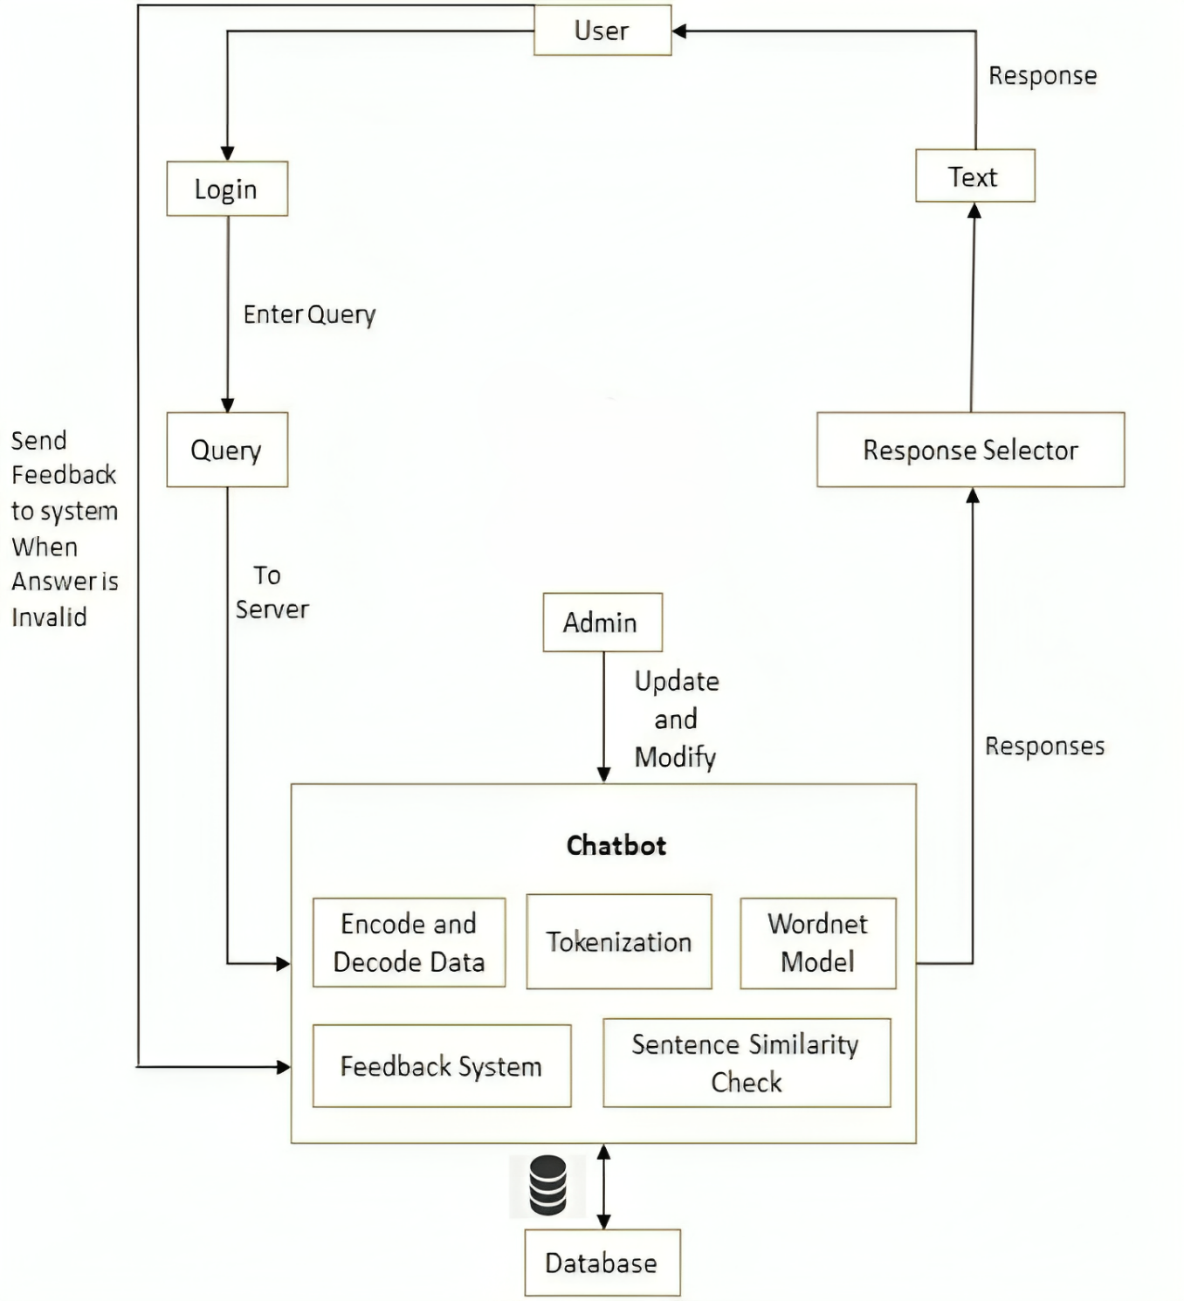

Fig 1 : College Chatbot system architecture

Here's a detailed breakdown of each element:

**1. User Interaction:**

* **User**: The user interacts with the chatbot, typically a student or a prospective student. The interaction begins with the user logging into the system to submit a query or ask a question.
* **Login**: The system requires users to authenticate, ensuring that the individual interacting with the chatbot is a valid user (such as a student or staff member).
* **Enter Query**: Once logged in, the user submits their query to the chatbot. This could be a question related to college services, courses, deadlines, or administrative procedures.

**2. Query Processing:**

* The **Query** is forwarded to the **Server**. Here, the server manages the back-end processing and the interaction between the chatbot and the user.

**3. Chatbot Engine:**

This is the core component of the system where various NLP (Natural Language Processing) and AI techniques are applied. The chatbot engine consists of several subsystems:

* **Encode and Decode Data**: This module is responsible for transforming the user's query into a format that the system can understand and process. Encoding translates the query into a machine-readable format, while decoding ensures the system's response is user-friendly.
* **Tokenization**: Tokenization breaks down the user’s query into individual tokens (words or phrases), allowing the system to process the question more efficiently by analyzing each token separately.
* **WordNet Model**: The WordNet model is a lexical database used by the chatbot to understand the meaning of words, synonyms, and relationships between different terms. This helps the system to identify relevant answers.
* **Sentence Similarity Check**: This component checks the semantic similarity between the user's query and the stored responses in the system. It helps the chatbot identify the most appropriate response based on how similar the user’s question is to previous queries.
* **Feedback System**: The chatbot includes a feedback mechanism that allows users to submit feedback when they receive an invalid or incorrect response. This is essential for improving the system's accuracy and performance.

**4. Response Generation:**

* **Response Selector**: Based on the processed query and sentence similarity check, the response selector chooses the most appropriate answer from the chatbot's database.
* **Text Response**: The selected response is then sent back to the user in the form of text, answering their query.

**5. Admin Interface:**

* **Admin**: An administrator oversees the system and is responsible for updating and modifying the chatbot's responses. When invalid answers are flagged by the feedback system, the admin reviews and improves the system’s responses.
* **Update and Modify**: The admin can update the chatbot’s knowledge base, ensuring that it stays up-to-date with the latest information, policies, and answers.

**6. Database:**

* The chatbot system is linked to a **Database** that stores all the necessary information, such as predefined responses, query logs, user information, and feedback data. The chatbot refers to this database to generate responses for user queries.

**7. Iterative Feedback Loop:**

* **Send Feedback to the System**: When the user receives an incorrect response, they can send feedback. This feedback loop enables the system to learn and improve, allowing the admin to make updates that enhance the chatbot’s accuracy and efficiency over time.
* Software Interface

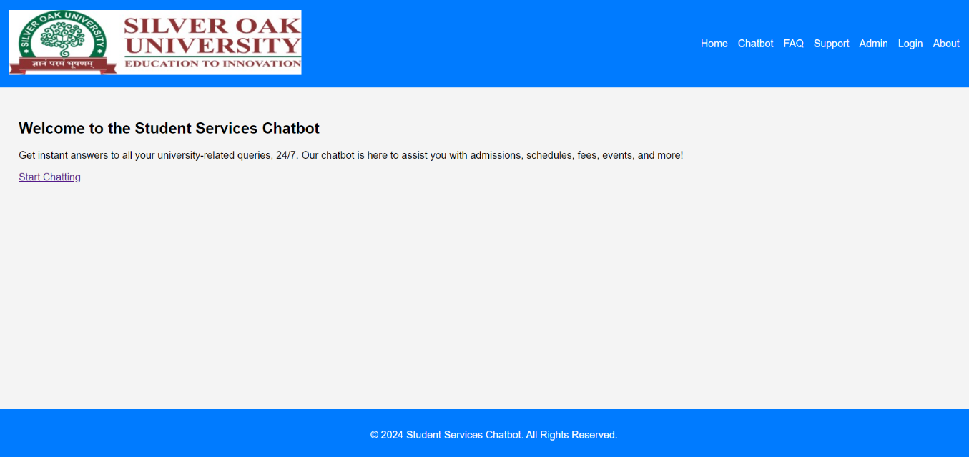

Fig 2 : Website interface

The screenshot displays the homepage of the "Student Services Chatbot" for Silver Oak University. It serves as an introduction to the chatbot system, highlighting its purpose to assist students with various university-related inquiries such as admissions, schedules, fees, and events. The design is minimal, with a clear call to action ("Start Chatting") that encourages users to engage with the chatbot.

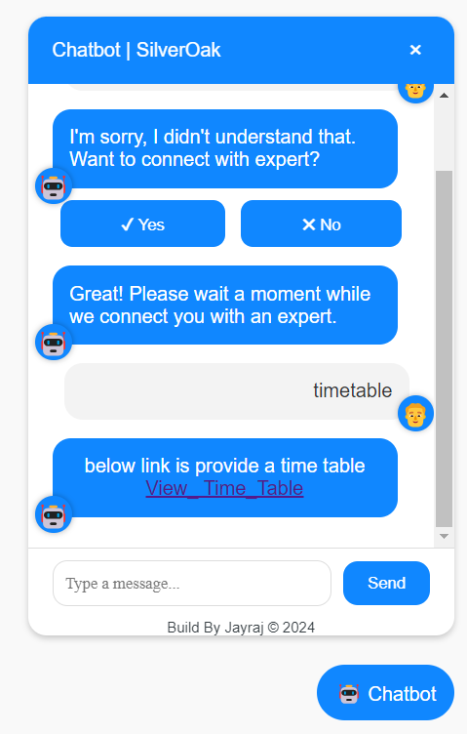

Fig 3 : Chatbot interface

The screenshot depicts a conversation within the "Chatbot | SilverOak" interface, where the chatbot is assisting a user with their query. The chatbot initially struggles to understand the user's request but offers to connect them with an expert for further assistance. When the user mentions "timetable," the chatbot responds by providing a link titled "View_Time_Table," which likely directs the user to the university's timetable information.

* Use Case of context identification

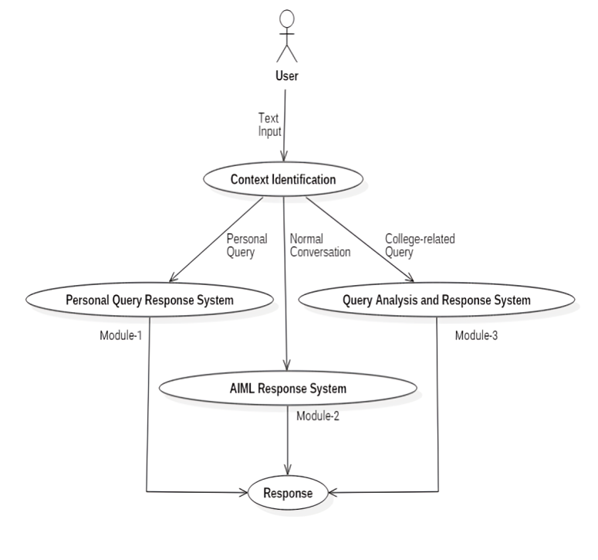Fig 3 :Use Case of context identification

flowchart of a chatbot system that handles different types of user input. Here's a breakdown:

**1. User:** The user initiates the interaction by providing text input.

**2. Context Identification:** The system analyzes the user's input to determine its context. This step classifies the input into one of three categories:

* **Personal Query:** The user is asking a question specific to their personal needs or information.
* **Normal Conversation:** The user is engaging in general conversation, perhaps asking casual questions or making general statements.
* **College-related Query:** The user is seeking information or assistance related to a college or academic context.

**3. System Routing:** Based on the context, the user's input is directed to the appropriate system:

* **Personal Query Response System (Module-1):** This system is designed to handle personal questions and requests.
* **Query Analysis and Response System (Module-3):** This system is specialized for analyzing and responding to college-related queries.
* **AIML Response System (Module-2):** This system is a general-purpose chatbot system that is used for normal conversational interactions.

**4. Response Generation:** Each system processes the user's input and generates an appropriate response.

**5. Response Output:** The response generated by the relevant system is then delivered back to the user.

* Activity Diagram of Normal Conversation Response

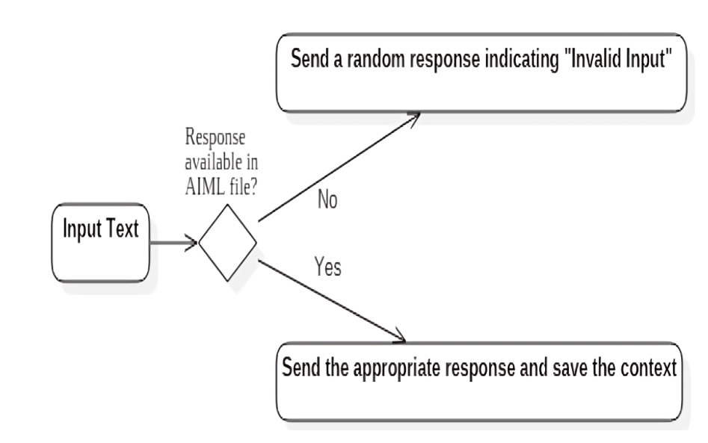

Fig 4 :Activity Diagram of Normal Conversation Response

The activity diagram shows the process of responding to a user input in a chatbot.

1. **Input Text:** The user input is received.
2. **Check for AIML response:** The system checks if there is a pre-defined response in the AIML file for the given input.
   * **No:** If there is no predefined response, the system sends a random response indicating "Invalid Input."
   * **Yes:** If a response is found, the system sends the appropriate response and saves the context of the conversation.

This diagram illustrates how a chatbot can handle user input by first looking for a specific response in a predefined knowledge base (AIML file) and falling back to a generic response if none is found. The context saving aspect allows the chatbot to remember previous interactions and maintain a more coherent conversation.

**5.Outcomes**

This section outlines the results of the project:

* **Key Findings**: Summarize the main results. For example, "The developed model achieved an accuracy of 85% in predicting patient outcomes."
* **Tools/Systems Developed**: Describe any tangible outputs. For example, "A web-based application was created to facilitate user interaction with the model."
* **Recommendations**: Provide suggestions based on the outcomes. For example, "Future research should focus on integrating the model with electronic health records for seamless data integration."
* **Reduced Administrative Workload**: By automating routine inquiries, administrative staff will spend less time answering repetitive questions and more time focusing on complex tasks.
* **Faster Query Resolution**: Students will receive answers to their questions instantly, improving their overall experience.
* **24/7 Availability**: The chatbot will offer round-the-clock support, ensuring that students can access information outside of regular office hours.
* **Real-time Data Access**: Integration with the university's databases ensures that students receive up-to-date and accurate information.
* **Scalability**: The system will be designed to handle a growing number of users, ensuring it remains efficient as demand increases.

**6.References**

* Mawani, N., Basnet, R., Alotaibi, A., & Khalid, S. A. “Chatbot-based higher education quality enhancement”, *Journal of Cases on Information Technology*, Vol. 22(1), pp. 29-39, January 2020.
* Navimipour, N. J., & Charantimath, P. M. “Developing an intelligent chatbot for university admission services: A case study”, *International Journal of Advanced Computer Science and Applications*, Vol. 7(11), pp. 1-6, November 2016.
* MDPI. “EduChat: An AI-Based Chatbot for University-Related Information”, *MDPI Journals*, Vol. 5, pp. 45-60, April 2023.
* SpringerLink. “Investigating Student Acceptance of an Academic Advising Chatbot”, *SpringerLink*, Vol. 12, pp. 102-112, May 2023.
* SpringerLink. “Design and Development of an Advising Chatbot for Student Support”, *SpringerLink*, Vol. 7, pp. 85-95, August 2023.
* **"Artificial Intelligence: A Modern Approach" by Stuart Russell and Peter Norvig** (2016)  
  This book provides a comprehensive overview of AI principles, including machine learning and NLP, which are crucial for developing chatbot systems.
* **"Natural Language Processing with Python" by Steven Bird, Ewan Klein, and Edward Loper** (2009)  
  A practical guide to NLP, offering techniques and tools for building AI-based systems that process and understand human language.
* **"Speech and Language Processing" by Daniel Jurafsky and James H. Martin** (2020)  
  Covers the fundamentals of speech and language processing, including the theories and algorithms used to develop conversational AI systems like chatbots.
* **"Deep Learning" by Ian Goodfellow, Yoshua Bengio, and Aaron Courville** (2016)  
  This book provides in-depth knowledge of deep learning techniques, which are often used in advanced AI-driven chatbots.
* **"Designing Bots: Creating Conversational Experiences" by Amir Shevat** (2017)  
  This book focuses on the design and development of chatbot systems, offering practical insights into creating intuitive and user-friendly conversational agents.
* **"Building Chatbots with Python" by Sumit Raj** (2019)  
  A hands-on guide to building chatbots using Python, a popular programming language for AI and NLP applications.
* **"Human-Computer Interaction" by Alan Dix et al.** (2004)  
  Provides a comprehensive overview of user interface design and human-computer interaction, which is essential for building user-friendly chatbots.
* **"Chatbots and Conversational Agents: A Practical Guide" by Matthew Green** (2021)  
  A detailed guide on building chatbots for various use cases, with a focus on the practical aspects of integrating AI in university services.
* **"AI and Chatbots in Education: Challenges and Opportunities" by Susan Page** (2020)  
  Explores the use of AI and chatbots in educational institutions, discussing the challenges and potential of these technologies in improving student services.
* **"The Elements of Statistical Learning" by Trevor Hastie, Robert Tibshirani, and Jerome Friedman** (2009)  
  A key reference for understanding machine learning techniques, which are essential for chatbot development and NLP applications.
* **"Learning from Data: A Short Course" by Yaser S. Abu-Mostafa, Malik Magdon-Ismail, and Hsuan-Tien Lin** (2012)  
  Provides a foundational understanding of data science and machine learning, crucial for training AI chatbots to improve over time.
* **"Designing the User Interface: Strategies for Effective Human-Computer Interaction" by Ben Shneiderman et al.** (2016)  
  A detailed book on designing effective user interfaces, which is important for ensuring that chatbots are intuitive and user-friendly.
* **"EduChat: An AI-Based Chatbot for University-Related Information" (2023)**  
  Explores the use of AI in developing chatbots that assist with university-related queries, focusing on admission, courses, and student services.  
  Source: MDPI Journals
* **"Investigating Student Acceptance of an Academic Advising Chatbot" (2023)**  
  Studies how students engage with academic advising chatbots in higher education institutions, providing insights into chatbot adoption.  
  Source: SpringerLink
* **"The Conversational Interface: Talking to Smart Devices" by Michael McTear, Zoraida Callejas, and David Griol** (2016)  
  Focuses on conversational agents and interfaces, exploring the underlying technologies that power voice- and text-based chatbot systems.